

Software Engineering Department
Braude College
Capstone Project Phase B – 61999
A System for diagnosing and providing solutions for growth deficiency in children

Group 25-2-D-18
Dr. Natali Levi
Bar Matzliah– Bar.Matzliah@e.braude.ac.il
Randa Assadi – Randa.Assadi@e.braude.ac.il

GitHub - https://github.com/BarBitton/Capstone
App - https://capstonephaseb-ftt.web.app/

Table of Contents
Table of Contents 2
1. Introduction 5
2. Development Process 6
2.1 Initial Planning and Requirements Gathering 6
2.2 Technology Selection 7
2.2.1 Decision Engine (“Model”) – Data, Logic, and Output Structure 8
2.3 Medical-Article Retrieval Layer (RAG) and Its Role in the Workflow 8
2.4 Role of Gemini: Human-Centered Explanation and Practical Guidance 9
2.5 Development Phases 9
2.5.1 UI/UX Design and Frontend Implementation 10
2.5.2 Backend and Firestore Integration 10
2.5.3 Growth Engine (Percentiles and Trend Analysis) 10
2.5.4 Retrieval + Explanation Layer 10
2.5.5 Contextual Chat and Feedback Loop 10
2.5.6 Finalization and Deployment 11
2.6 Diagrams 11
2.6.1 System Architecture Diagram 11
2.6.2 Activity Diagram 11
2.7 Challenges and Solutions 12
2.8 Tools and Technologies Used 13
2.8.1 Frontend 13
2.8.2 Backend and Cloud 13
2.8.3 Database and Security 13
2.8.4 AI and Knowledge Support 13
2.9 Scenes and Flow 13
2.10 Testing and Refinement 15
3. Results 16
3.1.1 Growth Assessment Accuracy (Rule-Based + Labeled Evaluation) 16
3.1.2 Effectiveness of Longitudinal Trend Analysis 17
3.1.3 Human-Friendly Explanation Quality (Gemini) 17
3.1.4 Medical Knowledge Support (RAG) Contribution 17
3.1.5 System Performance (Cloud Deployment) 17
3.1.6 Testing Outcomes 18
3.2 Key Achievements 18
3.2.1 Deterministic and Verifiable Growth Engine 18
3.2.2 Scalable Cloud Infrastructure 18
3.2.3 Clear Explanations for Non-Professional Users 18
3.2.4 Evidence-Supported Guidance via Medical Knowledge Retrieval 18
3.2.5 Continuation and Feedback Through Contextual Chat 18
3.3 Conclusions 18
3.4 Future Improvements 19
3.4.1 Expanded Growth Indicators 19
3.4.2 Improved Retrieval Methods 19
3.4.3 Broader Clinical Validation 19
3.4.4 Multi-Language Support 19
3.4.5 Advanced Usability Studies 19
3.4.6 Final Thoughts 20
4.References 20
SUS Questionere – System Usability Scale 41

Abstract
This project presents the design and implementation of a web-based decision support system for pediatric growth assessment, with a focus on identifying potential cases of Failure to Thrive (FTT). FTT is commonly evaluated through growth monitoring and longitudinal analysis of anthropometric measurements, yet its interpretation may be complex and time-consuming in routine clinical practice.
The developed system enables users to record children’s growth measurements, automatically compute growth percentiles based on standardized CDC growth charts, and analyze growth trends over time. A set of transparent, rule-based heuristics is applied to identify cases that are likely to represent growth deficiency, including low weight-for-age or length-for-age percentiles and significant downward crossing of percentile bands.
To enhance interpretability and user understanding, the system integrates a large language model (Google Gemini) to generate structured explanations and suggested next steps when concerning growth patterns are detected. The model is used strictly as a decision-support component, while core classification relies on deterministic clinical rules. A lightweight retrieval mechanism provides relevant medical context to the model in order to reduce ungrounded responses.
The system is implemented as a cloud-based web application using Firebase services, including Hosting, Cloud Functions, and Firestore. It supports longitudinal data storage, contextual chat functionality, and secure user-specific data isolation.
Evaluation was performed as an offline batch experiment on a labeled dataset. Out of 100 attempted cases, 96 were successfully scored (4 requests failed due to upstream timeouts), and the scoring pipeline compared the system’s final output against ground-truth labels. The system achieved an overall classification accuracy of 92.71% on the successfully processed subset (N = 96). The findings demonstrate the feasibility of combining deterministic growth analysis with explainable AI-generated guidance in a safe and maintainable decision-support framework.

1. Introduction
Failure to Thrive (FTT), also referred to as weight faltering [1][2], is a pediatric condition characterized by inadequate physical growth over time. It is commonly identified through growth monitoring using standardized growth charts, where children may present with persistently low weight-for-age or length-for-age percentiles, or with significant downward trends across percentile bands. Early identification of growth deficiency is essential, as prolonged growth failure may be associated with nutritional deficits, chronic medical conditions, developmental delays, and psychosocial risk factors.
In routine pediatric practice, growth assessment relies on repeated anthropometric measurements collected over time and their comparison to standardized references such as the Centers for Disease Control and Prevention (CDC)[20] and World Health Organization (WHO)[21] growth charts. Although these tools are well established, their interpretation is not always straightforward. Clinicians and caregivers must integrate multiple measurements, identify longitudinal patterns, and determine whether observed changes represent normal variation or clinically concerning decline. This process can be time-consuming and prone to inconsistency, particularly in busy clinical environments or in community and home-based monitoring settings. As a result, early warning signs of growth deficiency may be overlooked or identified only after significant delay.[3]
The growing availability of digital health systems and clinical decision support tools presents an opportunity to improve the consistency and accessibility of pediatric growth assessment.[15][18] By automating percentile calculations, tracking longitudinal trends, and presenting structured interpretations, such systems can assist users in recognizing potentially concerning growth patterns while maintaining transparency and clinical oversight.[13]
Phase A of this project focused on researching the clinical background of pediatric growth monitoring and evaluating the feasibility of developing an intelligent decision-support system for Failure to Thrive detection.[9] This phase included an extensive literature review of growth standards, diagnostic criteria, and existing clinical decision support systems.[4] The research findings highlighted the importance of combining deterministic growth-chart analysis with explainable reasoning, rather than relying solely on black-box prediction models. The conclusions of Phase A confirmed that a system integrating standardized growth references with explainable decision logic could provide meaningful support for early identification of growth concerns.
Building upon these findings, Phase B transitioned from research and feasibility analysis to full system development. The primary objective of this phase was to design and implement a functional web-based application capable of collecting pediatric growth data, computing standardized growth percentiles, analyzing longitudinal trends, and supporting users with clear and interpretable results. The developed system applies deterministic, rule-based heuristics to identify cases that are likely to represent Failure to Thrive, such as persistently low percentiles or significant downward crossing of growth bands over time.[16]
To enhance user understanding and interpretation, the system integrates a large language model (Google Gemini) [10] as a supportive explanatory component. The model is used to generate structured explanations and suggested next steps when concerning growth patterns are detected[12], while the core classification logic remains based on transparent clinical rules. This design ensures that the system functions as a decision-support tool rather than an autonomous diagnostic system, preserving clinical responsibility and interpretability.
The completed application includes secure user authentication, child profile management, longitudinal data storage, percentile visualization, automated growth assessment, and contextual conversational support. Together, these features aim to improve the accessibility, clarity, and consistency of pediatric growth monitoring. By completing the development phase in Phase B, the project demonstrates the practical feasibility of combining standardized clinical computations with explainable AI-based [2] guidance to support early recognition of pediatric growth deficiency.

2. Development Process
The development of the pediatric growth assessment system was a complex and multifaceted effort aimed at creating an accessible, explainable, and secure decision-support tool for identifying potential Failure to Thrive (FTT) patterns. The process began by translating Phase A research outcomes into clear technical requirements and then implementing each module incrementally, ensuring that the application remains reliable, user-friendly, and aligned with real-world usage by non-professional caregivers as well as clinicians.

2.1 Initial Planning and Requirements Gathering
During the initial planning phase, the team defined the core workflows that the system must support end-to-end:
- User authentication and privacy: each user accesses only their own data.
- Child profile management: create and manage child profiles and demographic details.
- Measurement entry and history: store repeated measurements over time to enable longitudinal analysis.
- Growth analysis: compute standardized percentiles and interpret trends.
- Decision support and explanation: provide an explainable “Likely FTT” indication and a clear rationale.
- Medical-article support layer (retrieval): consult a curated internal medical knowledge base before generating responses.
- Conversational follow-up: enable the user to continue interacting through chat, including providing feedback on the system’s output.
This planning emphasized two key principles:
- Deterministic core logic for consistent and verifiable decisions, and
- Human-centered explanations for users who are not medical professionals.

2.2 Technology Selection
To meet scalability, deployment simplicity, and privacy requirements, the system uses a cloud-first architecture:
- Frontend: React (with Vite) for rapid development and a responsive user interface.
- Backend: Firebase Cloud Functions (Node.js) with Express to expose API endpoints securely without server management.
- Database: Cloud Firestore for structured, user-isolated storage of children, assessments, and chat history.
- AI: Google Gemini for generating clear, human-friendly explanations and contextual responses, it was selected because it provides a reliable and developer-friendly API that integrates smoothly with a Firebase/Node.js serverless backend. Its strong natural-language generation capabilities support the project’s goal of producing clear, structured explanations for non-professional users, while keeping the core clinical decision logic deterministic and verifiable.
These technologies were selected to support secure authentication, reliable persistence of longitudinal records, and maintainable deployment.

2.2.1 Decision Engine (“Model”) – Data, Logic, and Output Structure
Unlike systems that train neural networks on images, this project’s core engine is a deterministic growth analysis pipeline supported by a curated medical knowledge base and an AI explanation layer.
Standardized Inputs
Each assessment uses validated structured inputs:
- child sex and age (months),
- weight (kg),
- length/height (cm),
- measurement date (timestamp),
- optional free-text context when relevant.
Percentile Computation (CDC LMS Tables)
The backend computes percentiles using CDC LMS reference tables (CSV files) for:
- Weight-for-Age (WFA)
- Length-for-Age (LFA)
Percentiles are computed deterministically and can be reproduced for the same input.
Explainable Likely FTT Heuristics
After computing percentiles, the system applies transparent decision rules to determine whether the case is Likely FTT. The rule logic focuses on high-signal indicators such as:
- low current percentiles in WFA and/or LFA, and
- longitudinal decline across percentile bands over time.
The output includes:
- computed percentiles,
- a Likely FTT flag (YES/NO),
- an explanation of which rule(s) triggered the decision.

2.3 Medical-Article Retrieval Layer (RAG) and Its Role in the Workflow
A curated medical knowledge base—built from medical articles and references provided by the team—is used as a decision-support layer to improve the relevance and safety of the system’s responses.
This retrieval step is performed before sending information into the conversational response generation, and it serves two primary purposes:
- Evidence-driven guidance selection
The system retrieves short, relevant excerpts from medical articles that match the current case (percentiles, growth pattern, and context). These excerpts function as supporting evidence that helps guide what recommendations are appropriate to present to the user.
- Reducing generic or ungrounded outputs
By injecting medically relevant context, the system reduces the chance of producing vague explanations that are not tailored to the situation.
The retrieval layer is executed before generating any conversational output. It selects the most relevant excerpts from the provided medical articles to determine which guidance is appropriate to present, and the selected evidence is then passed forward to the response generation stage.

2.4 Role of Gemini: Human-Centered Explanation and Practical Guidance
Google Gemini is integrated as an assistive layer designed to transform technical results into content that is understandable and actionable for users who are not medical professionals.
Gemini is used to:
- rephrase the results in clear and human-friendly language, avoiding overly clinical terminology,
- present structured outputs (summary → key indicators → reasoning → recommended next steps),
- adapt the explanation to the user’s level, especially for caregivers,
- suggest practical nutritional guidance (including meal ideas and recipes) is provided as supportive information only and should not be considered medical advice. Users are encouraged to consult a qualified healthcare professional for personalized clinical guidance.
Gemini is used to transform the system’s structured findings into clear and human-friendly language for users who are not clinicians. When nutrition-related guidance is relevant, the response may include practical meal ideas and simple recipes as actionable examples, while maintaining a supportive and non-diagnostic tone.
The system is designed so that the final response is not a “diagnosis,” but rather a structured explanation and guidance that supports responsible decision-making and encourages professional consultation when needed.

2.5 Development Phases
Development was executed in structured phases, with each phase producing a working increment and validating it through end-to-end testing.

2.5.1 UI/UX Design and Frontend Implementation
- Implemented authentication pages and protected routing.
- Built child management screens (create/select child).
- Implemented measurement entry and results screens.
- Added visualization and history views.
- Added a help section and clear user prompts to minimize incorrect input.

2.5.2 Backend and Firestore Integration
- Built an Express-based API on Firebase Cloud Functions.
- Implemented Firestore hierarchy for user-isolated data storage.
- Implemented validation and error-handling in endpoints.
- Ensured consistent payload structure between UI and backend.

2.5.3 Growth Engine (Percentiles and Trend Analysis)
- Implemented CDC LMS percentile computation.
- Implemented history retrieval for longitudinal comparisons.
- Implemented band-based trend detection and rule-based Likely FTT classification.
- Stored computed outputs for traceability.

2.5.4 Retrieval + Explanation Layer
- Implemented medical-article excerpt retrieval from the curated knowledge base.
- Injected retrieved context into explanation generation.
- Integrated Gemini to generate a structured, user-friendly explanation and guidance.

2.5.5 Contextual Chat and Feedback Loop
A conversational chat module was implemented to support continued interaction after the initial assessment. The chat enables the user to:
- ask follow-up questions about the explanation,
- provide clarifications or additional details (e.g., feeding behaviors, symptoms),
- give feedback or comments on the response received from the application.
The chat feature also enables the user to provide remarks on the response they received, such as missing context or clarifications. This allows subsequent answers to be adapted to the user’s feedback while preserving the deterministic growth assessment as the foundation of the system’s decision.

2.5.6 Finalization and Deployment
- Frontend deployed to Firebase Hosting.
- Backend deployed to Firebase Cloud Functions.
- Firestore used for persistence of child data, assessments, and chat history.
- Final UI refinements were applied to improve clarity and navigation.

2.6 Diagrams

2.6.1 System Architecture Diagram
The architecture diagram illustrates the major components:
- React Web UI (Firebase Hosting)
- Backend API (Cloud Functions + Express)
- Firestore database
- Medical knowledge base retrieval
- Gemini explanation and chat generation
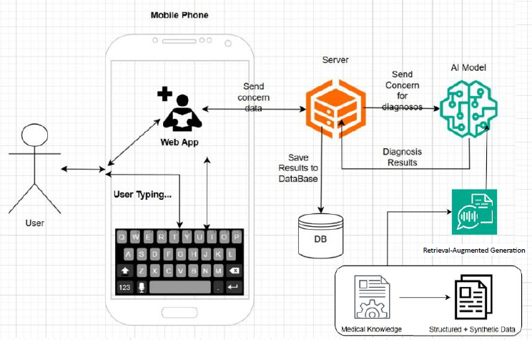
Figure X: System Architecture

2.6.2 Activity Diagram
The activity diagram outlines the user workflow:
- login → select child → enter measurement → validation → percentile computation → rule evaluation → retrieval → explanation → results → optional chat follow-up
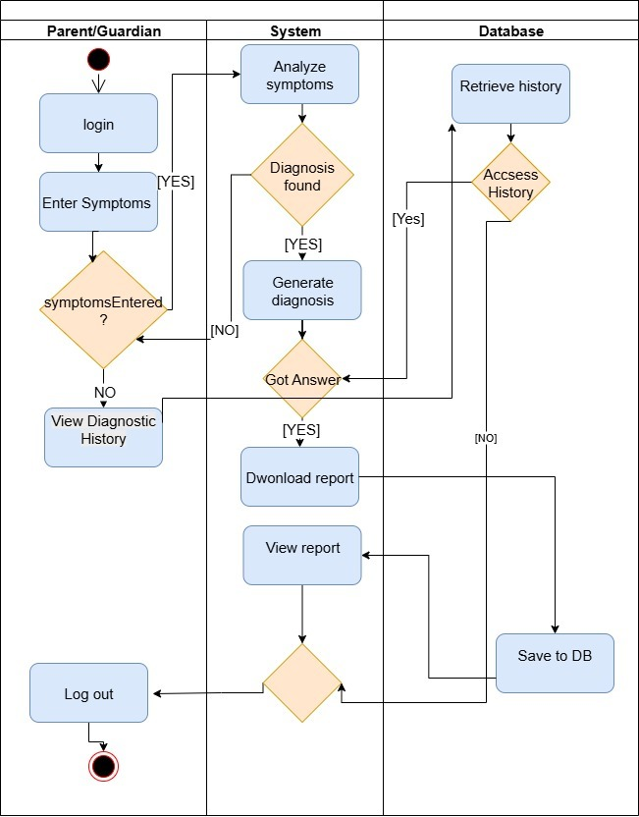
Figure Y: Activity Diagram

2.7 Challenges and Solutions

2.7.1 Correctness and Validation of Percentiles
- Problem: Percentile correctness can be affected by units, table indexing, and out-of-range values.
- Solution: Input validation, standardized units, caching of CDC tables, and spot-check verification.

2.7.2 Translating Clinical Indicators into Explainable Rules
- Problem: Growth assessment can be nuanced and longitudinal patterns must be interpreted consistently.
- Solution: Implemented transparent high-signal heuristics (low percentile thresholds + band-crossing trend detection) and stored rationales.

2.7.3 Ensuring Human-Friendly Explanations
- Problem: Users may not understand medical terminology and may misinterpret numeric outputs.
- Solution: Gemini generates structured explanations in simple language, emphasizes interpretation, and presents practical guidance such as meal ideas when appropriate.

2.7.4 Grounding Responses with Medical Articles
- Problem: Generic AI responses may be insufficient or not aligned to medical context.
- Solution: Medical-article excerpt retrieval is performed before explanation generation, ensuring responses are informed by curated medical references.

2.7.5 Interaction After Results (Feedback and Follow-Up)
- Problem: Users often have follow-up questions or want to add context after seeing the initial output.
- Solution: Contextual chat enables continued interaction and allows users to provide remarks and clarifications related to the received result.

2.8 Tools and Technologies Used

2.8.1 Frontend
- React + Vite
- Firebase Web SDK (Auth, Firestore)
- Chart visualization library

2.8.2 Backend and Cloud
- Firebase Cloud Functions (Node.js runtime)
- Express (API routing)
- firebase-admin (Firestore access)

2.8.3 Database and Security
- Cloud Firestore
- Firebase Authentication
- Firestore Security Rules (user isolation)

2.8.4 AI and Knowledge Support
- Google Gemini API (explanations and contextual chat)
- Curated medical knowledge base (articles/excerpts)
- Retrieval module (excerpt selection before response generation)

2.9 Scenes and Flow
This section describes the main user-facing screens of the system and the typical end-to-end workflow. It explains how a caregiver or clinician can complete a growth assessment, interpret the results, review historical measurements, and continue communication through the chat feature.

2.9.1 Login Screen
The Login Screen is the entry point to the system. Users authenticate using their credentials and gain access to a private workspace where all data is isolated per account. After successful login, the user is redirected to the main dashboard. If the user does not have an account, they can navigate to the registration option.

2.9.2 Registration Screen (Account Creation)
The Registration Screen enables new users to create an account by entering a valid email/username and a secure password. After registration is completed successfully, the system redirects the user to the application so they can begin creating child profiles and running assessments.

2.9.3 Home / Dashboard Screen
The Dashboard serves as the central navigation hub of the application. From this screen, users can access the child profiles list, initiate a new assessment, review previous results in the history view, and open the chat feature for follow-up questions or feedback.

2.9.4 Child Profiles Screen (Create / Select Child)
This screen allows the user to create and manage child profiles. Each profile stores the child’s basic details (such as sex and date of birth) and links to all growth measurements and assessments associated with that child. The user can select an existing child to continue monitoring, or create a new child profile to start a new record.

2.9.5 Create Child Profile Form
The Create Child Profile form collects the child details required for growth percentile computation. Accurate entry is important because sex and age directly affect the CDC percentile calculations. After saving, the child profile becomes available for assessment and history tracking.

2.9.6 New Assessment Screen (Measurement Entry)
This screen is used to enter a new growth measurement. The user enters the child’s weight and length/height using the required units. After clicking “Assess,” the request is sent to the backend for validation, percentile computation, and rule-based evaluation.

2.9.7 Results Screen (Percentiles + Likely FTT + Explanation)
The Results Screen displays the system output in a clear and structured format:
- the calculated CDC percentiles (e.g., weight-for-age and length-for-age),
- an interpretation of whether the growth trend is stable or declining,
- the Likely FTT indication (YES/NO) and its rationale,
- and a human-friendly explanation designed for caregivers who are not medical professionals.
When a concerning pattern is detected, the system generates a structured explanation that summarizes findings, highlights key indicators, and suggests practical next steps. When relevant, the guidance may include nutrition recommendations and simple meal ideas or recipes to support caregivers in applying suggestions.

2.9.8 History Screen (Longitudinal Tracking)
The History Screen provides longitudinal tracking of the child’s measurements and assessments. Users can view previous percentiles and outcomes, identify trends over time, and open past assessments to review the stored rationale and explanation. This screen supports traceability by showing how decisions were derived from the accumulated history.

2.9.9 Assessment Details View (Past Result Review)
This view allows users to open a specific past assessment and review all stored information, including the original measurements, computed outputs, and the structured explanation. This supports follow-up discussions and makes it possible to compare results across different dates.

2.9.10 Chat Screen (Follow-Up and User Feedback)
The Chat Screen enables the user to continue interacting after receiving an assessment result. This feature supports two main goals:
- Follow-up questions: users can ask clarifying questions about the explanation, percentiles, trend, or recommended next steps.
- User feedback and remarks: users can provide comments or additional context about the response they received from the application (for example, missing details about feeding habits or symptoms). This allows the system to respond more accurately in subsequent turns while preserving the deterministic growth assessment as the core decision foundation.
Chat messages are stored per child profile, ensuring that continued communication remains context-aware and relevant to the child’s history.

2.9.11 Learn More About FTT (General Information)
The “Learn More About FTT” screen provides general background information in simple language for users who are not medical professionals. It explains what FTT is, common indicators and possible causes, and why monitoring growth over time is important. The content is intended for education and awareness only, helping users better understand the topic and prepare relevant questions for healthcare professionals when needed.

2.10 Testing and Refinement
Testing was performed across multiple layers to ensure correctness, stability, and usability.
Testing & Validation Table
Test Name | Description | Status
Login Functionality | Validate authentication and protected access | Pass
Child Profile Creation | Verify child profiles are stored correctly per user | Pass
Measurement Entry | Verify measurements are accepted and validated | Pass
Percentile Computation | Spot-check CDC percentile computation outputs | Pass
Trend Detection | Verify longitudinal decline detection across history | Pass
Likely FTT Decision | Validate rule outcomes on edge cases | Pass
Retrieval Step | Verify relevant medical excerpts are retrieved before response generation | Pass
Explanation Clarity | Ensure Gemini output is structured and understandable | Pass
Recipe/Nutrition Suggestions | Verify practical guidance appears when appropriate | Pass
Chat Continuation | Verify chat messages are stored and context is used | Pass
Error Handling | Verify invalid inputs return safe errors | Pass
API Response Time | Measure response time with and without AI layer | Pass
Testing & Validation / Usability (SUS)
System usability was evaluated using the System Usability Scale (SUS) questionnaire (10 items, 5-point Likert scale). Ten participants completed a short task flow including login, creating/selecting a child profile, entering a new measurement, reviewing the results, and opening the chat for a follow-up question. SUS scores ranged from 72.5 to 92.5, with a mean score of 83.1 (SD = 6.1, median = 85.0), indicating above-average usability. Participants reported that the assessment flow was easy to follow and that the results page provided clear, structured explanations that were understandable even for non-professional users. The most common improvement suggestions were to add stronger unit hints near the measurement fields and to make the “History” navigation more prominent.

3. Results
3.1 Results

3.1.1 Growth Assessment Accuracy (Rule-Based + Labeled Evaluation)
- The system demonstrated reliable performance in identifying growth patterns consistent with potential Failure to Thrive (FTT) using deterministic percentile computation (CDC LMS tables) and explainable rule-based logic.
- Evaluation was conducted using a labeled dataset of pediatric cases. The system achieved an overall classification agreement (accuracy) of 92.71% on N = 96 cases, based on the final fixed configuration.
- The main benefit of the deterministic core was consistent outputs: identical inputs produce identical percentiles and identical Likely-FTT decisions, supporting verification and reproducibility.

3.1.2 Effectiveness of Longitudinal Trend Analysis
- The longitudinal component successfully identified clinically meaningful downward trends across percentile “bands” when historical measurements were available.
- Trend detection improved sensitivity compared to single-measurement analysis, particularly in borderline cases where the current percentile alone may not indicate concern but the decline over time is significant.

3.1.3 Human-Friendly Explanation Quality (Gemini)
- The Gemini explanation layer improved interpretability by converting numeric outputs (percentiles and trend findings) into clear language for caregivers who are not medical professionals.
- Explanations were consistently structured (summary → indicators → reasoning → next steps → disclaimer), which reduced confusion and helped users understand why the system flagged a case.
- When appropriate, the system provided practical nutrition guidance, including meal ideas and simple recipes, supporting actionable steps for caregivers.

3.1.4 Medical Knowledge Support (RAG) Contribution
- RAG was selected to ensure that explanations and recommendations are anchored in trusted medical references, rather than relying solely on the language model’s general knowledge.

- Because the system targets non-professional users, it is critical that guidance is consistent and case-relevant; retrieving short excerpts from the provided medical articles helps decide what content is appropriate to present before generating a conversational response.

- This approach reduces generic or potentially ungrounded outputs, improves reproducibility of guidance across similar cases, and preserves system transparency—since the Likely-FTT decision remains fully deterministic and independent of the LLM.

3.1.5 System Performance (Cloud Deployment)
- The Firebase-based architecture provided stable deployment with secure user isolation and persistent longitudinal history storage.
- The assessment flow was responsive for typical usage. Average response time for percentiles and rule evaluation (without LLM) was 0.6 seconds, while cases requiring AI explanation averaged 3.9 seconds due to model processing time.
- The system maintained reliable functionality across repeated use, including saving and retrieving assessments and chat history from Firestore.

3.1.6 Testing Outcomes
- Testing covered core flows end-to-end: login, child creation, assessment submission, percentile computation, Likely-FTT decision logic, explanation generation, history viewing, and chat continuation.
- Unit and integration checks verified correctness of:
  - CDC table loading and percentile calculation,
  - trend detection over history,
  - correct gating of Gemini calls (only when needed),
  - correct Firestore persistence and retrieval.
- The system passed functional stability tests under repeated runs and typical user workflows.

3.2 Key Achievements

3.2.1 Deterministic and Verifiable Growth Engine
Achieved standardized CDC percentile computation and explainable rule-based classification, enabling reproducible outputs and easier validation.

3.2.2 Scalable Cloud Infrastructure
Successfully integrated Firebase Hosting, Cloud Functions, and Firestore to deliver a fully deployed system with secure user-specific data isolation.

3.2.3 Clear Explanations for Non-Professional Users
Delivered structured, human-friendly explanations through Gemini, enabling caregivers to understand results without medical training, while still preserving clinical responsibility.

3.2.4 Evidence-Supported Guidance via Medical Knowledge Retrieval
Integrated a curated medical knowledge base and a retrieval step that supports response quality by grounding recommendations and improving relevance.

3.2.5 Continuation and Feedback Through Contextual Chat
Implemented a contextual chat module that allows users to ask follow-up questions and add remarks about the result they received, increasing usability and making the system more interactive and supportive.

3.3 Conclusions
The Pediatric Growth Assessment System successfully addresses key challenges in growth monitoring by providing an accessible and explainable decision-support workflow. By combining standardized growth-chart computations (CDC percentiles), longitudinal trend analysis, and transparent rule-based logic, the system produces consistent and verifiable indications of potential growth concerns. The integration of Gemini adds value by transforming technical findings into human-friendly explanations, practical guidance, and continued conversational support, making the output more understandable for caregivers while still being relevant for clinical review.
Key takeaways include:
- Deterministic percentile and rule-based logic provides a trustworthy foundation for decision support.
- Longitudinal trend interpretation is essential for detecting concerning growth patterns that may not appear in a single measurement.
- AI-generated explanations are most effective when they focus on clarity, structure, and responsible language, especially for non-professional users.
- Providing curated medical context before generating responses improves relevance and reduces generic guidance.
- Enabling follow-up communication through chat improves usability and allows users to clarify context after receiving results.

3.4 Future Improvements
Although the system achieved its primary objectives, several enhancements can further strengthen its impact:

3.4.1 Expanded Growth Indicators
Add additional standardized indicators (e.g., BMI-for-age when applicable, weight-for-length, head circumference where relevant) to broaden clinical coverage.

3.4.2 Improved Retrieval Methods
Replace lightweight keyword-based retrieval with embedding-based semantic search to improve relevance and robustness across varied terminology.

3.4.3 Broader Clinical Validation
Perform larger-scale validation with clinician review, additional datasets, and agreement measures (e.g., Cohen’s Kappa) to assess clinical alignment.

3.4.4 Multi-Language Support
Add multilingual explanations and UI translations to improve accessibility for diverse user populations.

3.4.5 Advanced Usability Studies
Conduct extended usability evaluation (more participants, scenarios, and structured user feedback) to refine UI clarity and guidance effectiveness.

3.4.6 Final Thoughts
This project demonstrates the feasibility of combining standardized clinical computation with explainable AI support in a cloud-deployed system that is both maintainable and user-friendly. By providing consistent growth assessment, grounded guidance, and conversational follow-up, the system supports early recognition of potential growth deficiency patterns and encourages responsible clinical consultation when needed. With continued development and expanded validation, the system can evolve into a stronger decision-support platform for pediatric growth monitoring and caregiver education.

4.References
- Nationwide Children's Hospital. (n.d.). Failure to Thrive (FTT). Retrieved from https://www.nationwidechildrens.org/conditions/failure-to-thrive
- Stryker, C., & Kavlakoglu, E. (2024). What is artificial intelligence (AI)? IBM. Retrieved from https://www.ibm.com/think/topics/artificial-intelligence
- Evans, R. S. (2016). Electronic Health Records: Then, Now, and in the Future. Yearbook of Medical Informatics, 25(S 01), S48–S61. https://doi.org/10.15265/IYS-2016-s006
- Nationwide Children's Hospital. (n.d.). Failure to Thrive (FTT). Retrieved from https://www.nationwidechildrens.org/conditions/failure-to-thrive?utm
- EpicShare. (n.d.). Small Babies Grow Stronger with Improved Nutrition Monitoring. Retrieved from https://www.epicshare.org/share-and-learn/small-babies-grow-stronger-with-improved-nutrition-monitoring
- Dewey, F. E., Grove, M. E., Pan, C., Goldstein, B. A., Bernstein, J. A., Chaib, H., ... & Ashley, E. A. (2019). Development of syndrome-specific growth charts in EHRs. Journal of Biomedical Informatics, 93, 103147. https://www.ncbi.nlm.nih.gov/pmc/articles/PMC6815511
- American Academy of Pediatrics. (2024). Special Requirements of Electronic Health Records in Pediatrics. Pediatrics, 154(4), e2024068509. https://doi.org/10.1542/peds.2024-068509
- Empeek. (n.d.). Epic vs Cerner: EHR Systems Comparison. Retrieved from https://empeek.com/insights/epic-vs-cerner
- Sarker, A., & Gonzalez, G. (2024). Cancer detection with AI. Journal of Medical Systems, 48(2). https://www.ncbi.nlm.nih.gov/pmc/articles/PMC11047988/
- Zhang, L., & Smith, J. (2024). Limitations of AI in Pediatric Growth Disorders. Pediatric Health Review, 12(1), 22–30. https://www.ncbi.nlm.nih.gov/pmc/articles/PMC11941653/
- Kreimeyer, K., Foster, M., Pandey, A., Arya, N., Halford, G., Jones, S. F., ... & Kumar, A. (2019). Natural language processing of clinical notes on chronic diseases: Systematic review. Journal of the American Medical Informatics Association, 26(4), 345–353. https://www.ncbi.nlm.nih.gov/pmc/articles/PMC6528438/
- Liu, Y., Chen, Q., & Wang, Y. (2022). A deep language model for symptom extraction from clinical text. Journal of Biomedical Informatics, 128, 104058. https://www.ncbi.nlm.nih.gov/pmc/articles/PMC9074854/
- Wu, H. Y., & Luo, L. (2020). NLP tools in extracting biomedical concepts. BMC Medical Informatics and Decision Making, 20, 52. https://bmcmedinformdecismak.biomedcentral.com/articles/10.1186/s12911-020-01352-2
- John Snow Labs. (n.d.). Clinical NLP Platform. Retrieved from https://www.johnsnowlabs.com/clinical-nlp/
- Bubeck, S., Chandrasekaran, V., Eldan, R., Gehrke, J., Horvitz, E., Kamar, E., ... & Zhang, Y. (2023). Sparks of artificial general intelligence: Early experiments with GPT-4. Microsoft Research. https://www.microsoft.com/en-us/research/publication/capabilities-of-gpt-4-on-medical-challenge-problems/
- Williams, J., & Lee, K. (2023). AI in digital health: A comprehensive review. PLOS Digital Health, 2(3), e0000198. https://journals.plos.org/digitalhealth/article?id=10.1371/journal.pdig.0000198
- Penn State University. (2023). Improving efficiency and reliability of AI medical summarization. Retrieved from https://www.psu.edu/news/information-sciences-and-technology/story/improving-efficiency-reliability-ai-medical-summarization
- Lin, H. C., Wang, Z., & Xu, Y. (2022). AI in clinical documentation: From assistance to automation. Journal of the American Medical Informatics Association, 29(5), 789–797. https://pmc.ncbi.nlm.nih.gov/articles/PMC8826344/
- Peng, Y., Yan, X., & Lu, Z. (2020). Transfer learning in biomedical NLP: A case study on BERT models. arXiv preprint. https://arxiv.org/abs/2005.14165
- https://www.cdc.gov/index.html
- https://www.who.int/


Software Engineering Department
Braude College
Capstone Project Phase B – 61999
A System for diagnosing and providing solutions for growth deficiency in children
USER GUIDE
Group 25-2-D-18
Dr. Natali Levi
Bar Matzliah– Bar.Matzliah@e.braude.ac.il
Randa Assadi – Randa.Assadi@e.braude.ac.il

GitHub - https://github.com/BarBitton/Capstone
App - https://capstonephaseb-ftt.web.app/

User Guide

Welcome to the Pediatric Growth Assessment System
The Pediatric Growth Assessment System is a web-based application designed to support caregivers and clinicians in monitoring a child’s growth over time and identifying potential patterns consistent with Failure to Thrive (FTT). The system calculates growth percentiles based on standardized CDC growth charts, analyzes trends across multiple measurements, and provides a clear, human-friendly explanation of the results. When relevant, the system also suggests practical nutrition guidance, including meal ideas and recipes, to help caregivers apply recommendations in everyday life.
This manual will guide you through system requirements, account setup, and the main workflows: creating a child profile, entering measurements, reviewing results, viewing history, and continuing communication through the chat feature.

2. System Requirements
- Device: Desktop or laptop computer (recommended) or mobile device
- Browser: Google Chrome / Microsoft Edge / Firefox (latest versions recommended)
- Internet Connection: Stable internet connection required
- Permissions Required: Internet access (no camera permissions required)

2.1 Accessing the System

Open the Application
- Open your web browser.
- Navigate to the system URL (provided with the project submission).
- You will be directed to the login screen.

2.2 Account Setup

Create an Account (Register)
- Click Register on the login page.
- Enter your email/username and create a secure password.
- Click Create Account.
- After successful registration, you will be redirected to the main dashboard.
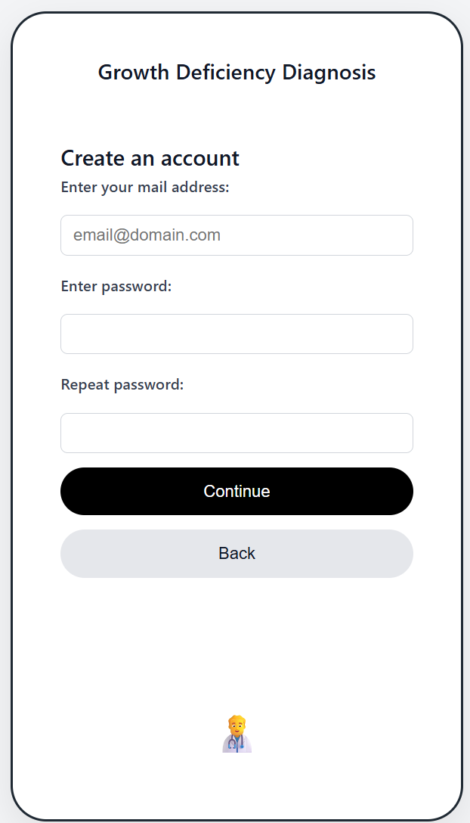
Figure 2.2: Registration Screen

Login to Your Account
- On the login page, enter your registered email/username and password.
- Click Sign In to access the system.

Figure 2.2.1: Login Screen

2.3 Navigating the System
After logging in, you will be able to access the main areas of the application:
- Children / Profiles
Create and manage child profiles. Each profile stores demographic data and growth history.
- New Assessment
Enter a new measurement (weight and length/height) and run an assessment.
- Results
Displays computed percentiles, trend interpretation, Likely FTT indication (when applicable), and a structured explanation in human-friendly language.
- History
Shows all previous assessments and measurements for the selected child, including charts and stored explanations.
- Chat (Follow-up Communication)
Enables continued interaction after receiving results on the bottom of the screen of each assessment also can be found on history assessment on the bottom screen. Users can ask follow-up questions and provide remarks or clarifications about the result they received.
- Settings
Logout from the system.
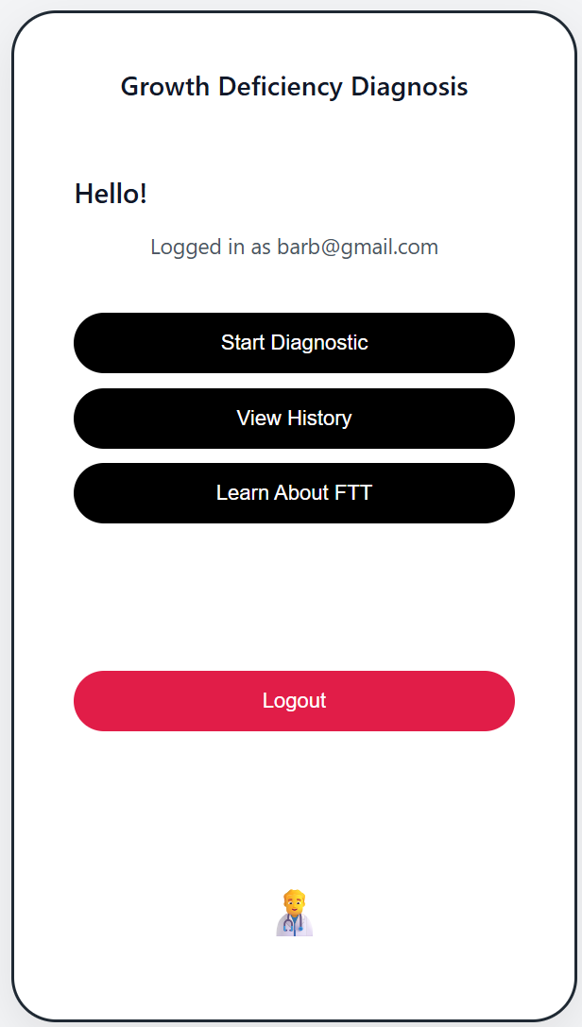
Figure 2.3: Home (Dashboard) Screen
The Dashboard serves as the central navigation hub of the application. From this screen, users can access the child profiles list, initiate a new assessment, review previous results in the history view, and open the chat feature for follow-up questions or feedback.
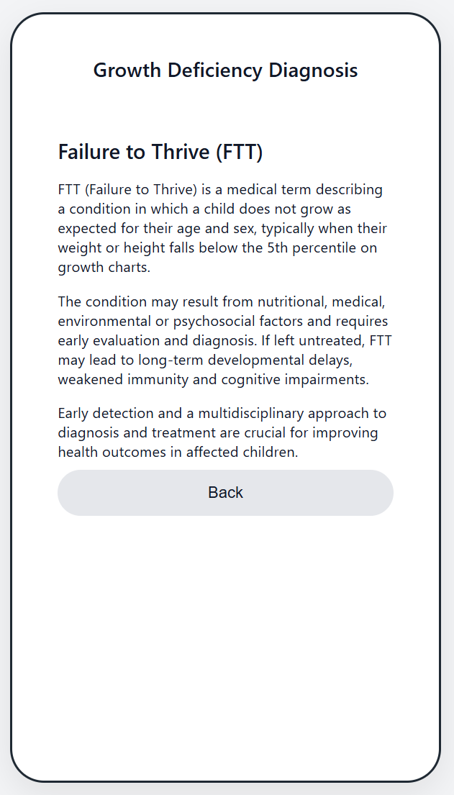
Figure 2.3.1: Learn More About FTT Screen
The “Learn More About FTT” screen provides general background information in simple language for users who are not medical professionals. It explains what FTT is, common indicators and possible causes, and why monitoring growth over time is important. The content is intended for education and awareness only, helping users better understand the topic and prepare relevant questions for healthcare professionals when needed.

2.4 Growth Assessment Process

Step 1: Select or Create a Child Profile
- Open the Children / Profiles section.
- Create a new child profile or select an existing child from the list.
- Verify that the profile details (sex and date of birth) are correct, since they affect percentile calculations.

Step 2: Enter Measurements
- Open New Assessment (or the assessment form under the selected child).
- Enter:
  - Measurement date
  - Weight (kg)
  - Length/Height (cm)
- Click Assess to submit the measurement.

Step 3: System Processing
After submission, the system performs the following:
- Validation: verifies that the input values are valid and within expected ranges.
- Percentile Calculation: computes CDC-based percentiles (e.g., weight-for-age and length-for-age).
- Trend Analysis: compares the new measurement to the child’s history to identify meaningful changes over time.
- Decision Support: applies explainable rules to determine whether the case is likely to indicate growth deficiency.
- Medical Context Retrieval (Knowledge Support): retrieves short relevant excerpts from a curated medical knowledge base before generating the final explanation.
- Explanation Output (Gemini): generates a structured explanation in clear language for non-professional users, and provides practical guidance when appropriate.
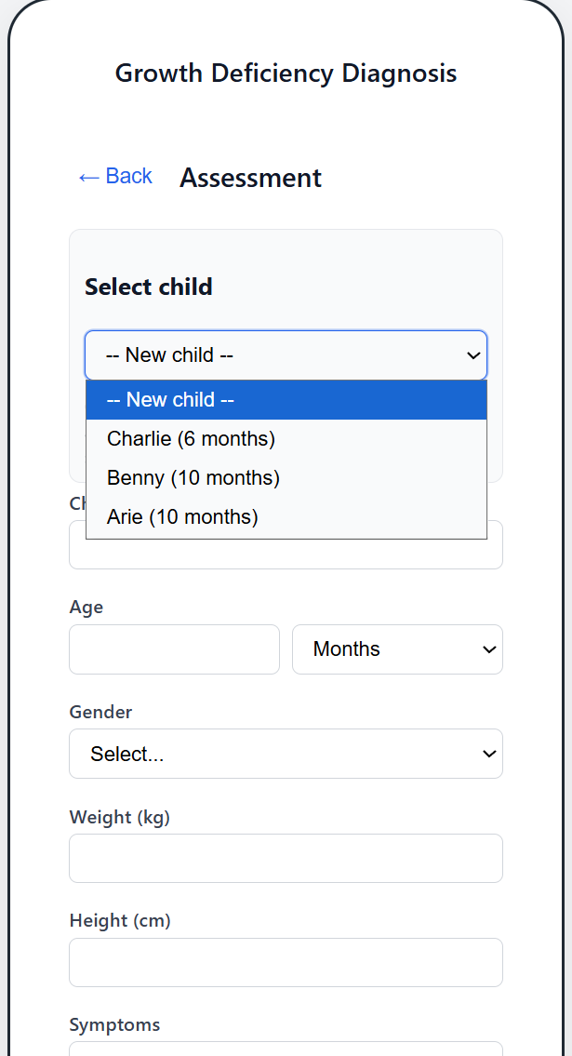
Figure 2.4: Child Profiles Screen
This screen allows the user to create and manage child profiles. Each profile stores the child’s basic details (such as sex and date of birth) and links to all growth measurements and assessments associated with that child. The user can select an existing child to continue monitoring, or create a new child profile to start a new record.
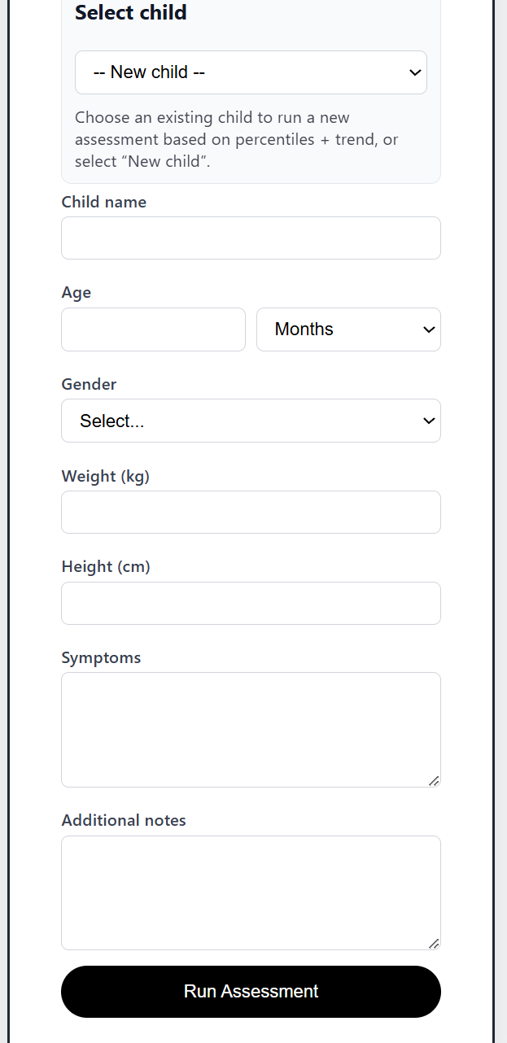
Figure 2.4.1: Create Child Profile Form
The Create Child Profile form collects the child details required for growth percentile computation. Accurate entry is important because sex and age directly affect the CDC percentile calculations. After saving, the child profile becomes available for assessment and history tracking.
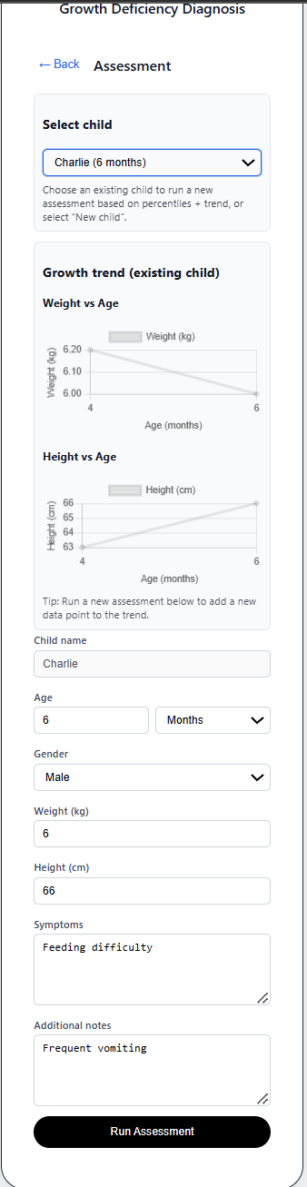
Figure 2.4.2: New Assessment Screen (Measurement Entry)
This screen is used to enter a new growth measurement. The user enters the child’s weight and length/height using the required units. After clicking “Assess,” the request is sent to the backend for validation, percentile computation, and rule-based evaluation.

3. Understanding the Results
The results screen includes:

Percentiles
- Weight-for-Age (WFA) Percentile: indicates how the child’s weight compares to peers of the same age and sex.
- Length-for-Age (LFA) Percentile: indicates how the child’s length/height compares to peers of the same age and sex.

Trend Interpretation
The system highlights whether growth appears stable or whether there is a significant downward trend across percentile bands.

Likely FTT Indication
- Likely FTT: YES
A concerning growth pattern was identified based on low percentiles and/or a significant decline over time. The system will provide a structured explanation and recommended next steps.
- Likely FTT: NO
No major concerning growth pattern was detected based on the current rules. The system will still provide a summary of findings and may suggest general monitoring guidance.

Explanation and Guidance
The explanation is structured to help non-professional caregivers understand the result. It may include:
- a short summary of what the measurements indicate,
- the key indicators (percentiles and trend),
- recommended next steps (e.g., monitoring frequency, discussing with a clinician),
- practical nutrition support including meal ideas and recipes when relevant.
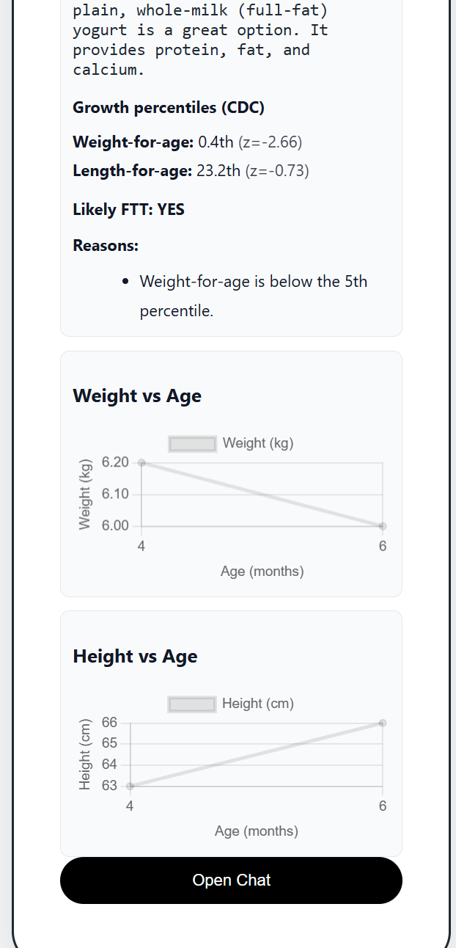
Figure 3: Results Screen
The Results Screen displays the system output in a clear and structured format:
- the calculated CDC percentiles (e.g., weight-for-age and length-for-age),
- an interpretation of whether the growth trend is stable or declining,
- the Likely FTT indication (YES/NO) and its rationale,
- and a human-friendly explanation designed for caregivers who are not medical professionals.
When a concerning pattern is detected, the system generates a structured explanation that summarizes findings, highlights key indicators, and suggests practical next steps. When relevant, the guidance may include nutrition recommendations and simple meal ideas or recipes to support caregivers in applying suggestions.

3.1 Using the Chat for Follow-Up and Feedback
After receiving results, users may want to clarify details or provide additional context (e.g., feeding habits, appetite changes, illness, symptoms). The Chat feature supports this by enabling continued communication.

How to Use Chat
- Open the Chat tab for the selected child.
- Enter your question or remark regarding the result you received.
- Send the message.
- The system will respond in a structured, user-friendly way while considering the child’s stored history and assessment results.
This feature also allows the user to provide feedback on the explanation (for example, correcting missing context), which improves the usefulness of subsequent answers.
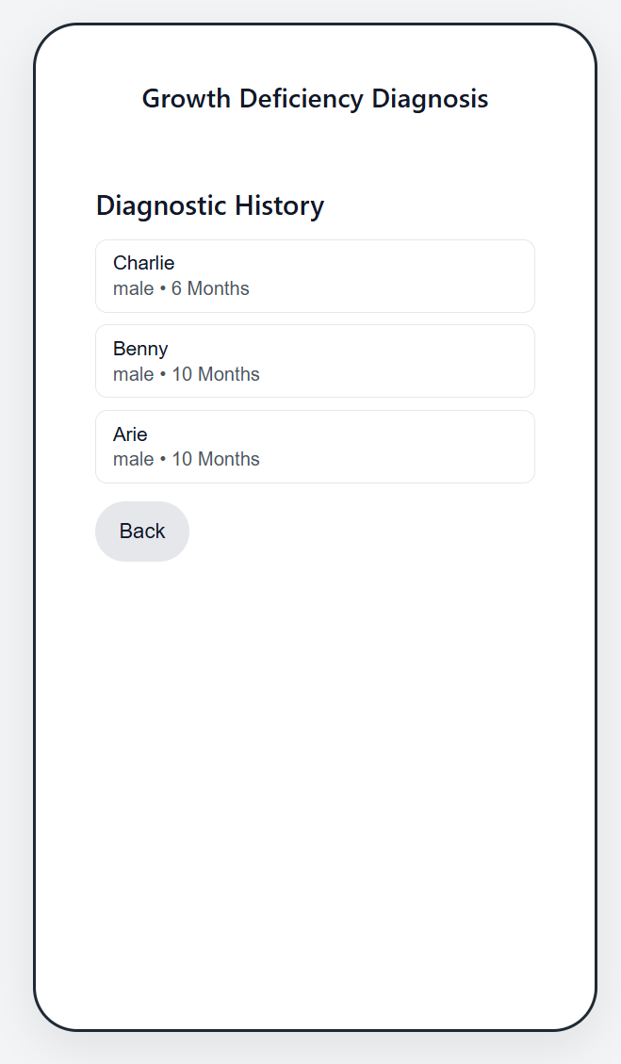
Figure 3.1: History Screen
The History Screen provides longitudinal tracking of the child’s measurements and assessments. Users can view previous percentiles and outcomes, identify trends over time, and open past assessments to review the stored rationale and explanation. This screen supports traceability by showing how decisions were derived from the accumulated history.
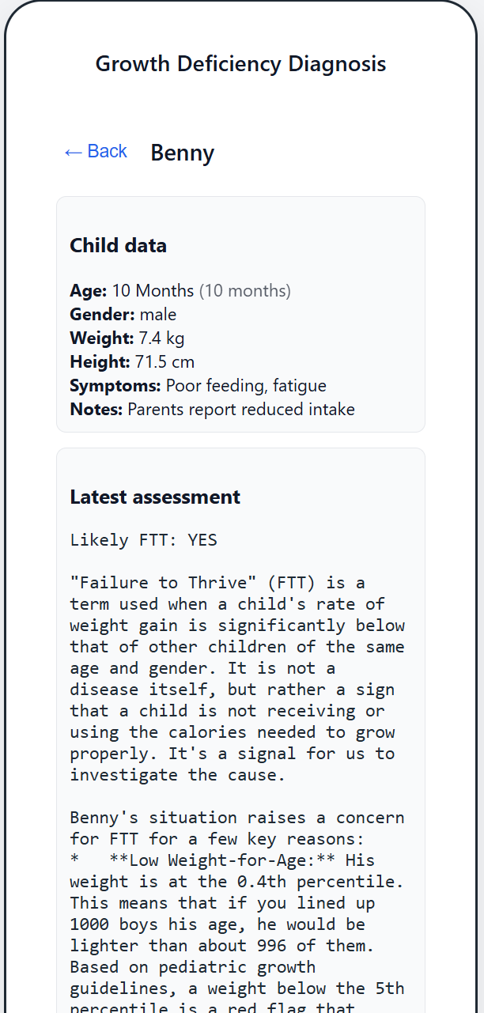
Figure 3.2: Assessment Details View
This view allows users to open a specific past assessment and review all stored information, including the original measurements, computed outputs, and the structured explanation. This supports follow-up discussions and makes it possible to compare results across different dates.
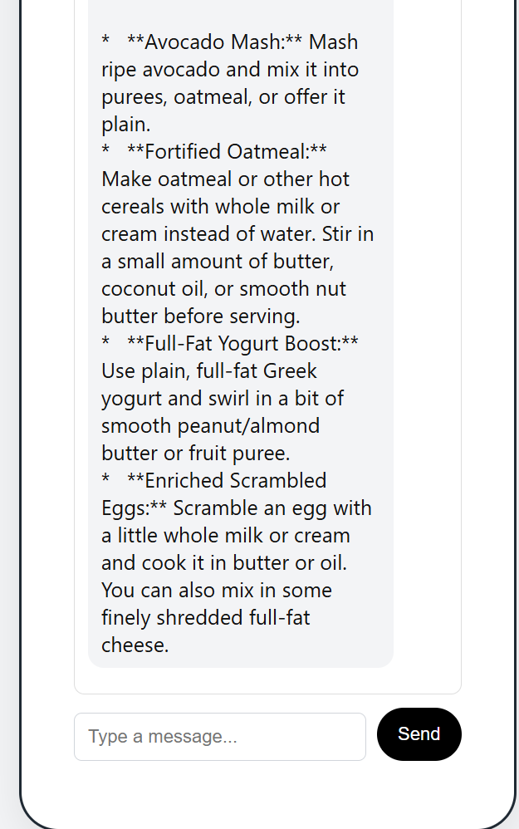
Figure 3.3: Chat Screen
The Chat Screen enables the user to continue interacting after receiving an assessment result. This feature supports two main goals:
- Follow-up questions: users can ask clarifying questions about the explanation, percentiles, trend, or recommended next steps.
- User feedback and remarks: users can provide comments or additional context about the response they received from the application (for example, missing details about feeding habits or symptoms). This allows the system to respond more accurately in subsequent turns while preserving the deterministic growth assessment as the core decision foundation.
Chat messages are stored per child profile, ensuring that continued communication remains context-aware and relevant to the child’s history.

4. Troubleshooting
- Cannot log in
  - Verify the email/username and password.
  - Ensure internet connection is stable.
  - Try refreshing the page.
- Assessment fails or returns an error
  - Verify that weight and length/height were entered in the correct units (kg, cm).
  - Ensure measurement date is valid.
  - Retry after a few seconds if the server is busy.
- Results seem unclear
  - Review the percentile and trend sections first.
  - Use the Chat feature to ask follow-up questions or provide more context.
- Slow response
  - Check internet connection.
  - Note that generating explanations may take longer than percentile calculations because it involves AI processing.
- History is missing records
  - Confirm you selected the correct child profile.
  - Refresh the page and check again.



Software Engineering Department
Braude College
Capstone Project Phase B – 61999
A System for diagnosing and providing solutions for growth deficiency in children
Maintenance Guide
Group 25-2-D-18

Dr. Natali Levi
Bar Matzliah– Bar.Matzliah@e.braude.ac.il
Randa Assadi – Randa.Assadi@e.braude.ac.il

GitHub - https://github.com/BarBitton/Capstone
App - https://capstonephaseb-ftt.web.app/

Maintenance Guide
This guide explains how to run, deploy, maintain, and troubleshoot the Pediatric Growth Assessment System. The system is deployed on Firebase and consists of a React frontend, a Node.js backend hosted on Firebase Cloud Functions (Express), and a Cloud Firestore database. Google Gemini is integrated server-side for explanation generation and contextual chat. A curated medical knowledge base is maintained to support evidence-based guidance via a retrieval (RAG) step executed before response generation.

1. Logical System Decomposition
The system is maintained as five logical modules:
- Web Client (UI Layer)
Responsible for authentication, child selection, measurement entry, results presentation, history visualization, and chat UI.
- API Layer (Cloud Functions + Express)
Entry point for all backend requests. Validates input, orchestrates the assessment pipeline, writes/reads Firestore, and triggers LLM responses when required.
- Deterministic Assessment Engine
CDC percentile computation + rule-based Likely-FTT logic + trend evaluation using historical measurements.
- Medical Knowledge Support (RAG) + Response Generation
Retrieves case-relevant excerpts from curated medical sources to guide what recommendations are appropriate, then uses Gemini to render the explanation in clear language for non-clinical users (and provide practical nutrition ideas when relevant).
- Offline Evaluation & Calibration Tooling
Scripts for building the knowledge base, calibrating rules, and running batch scoring to compute accuracy.

2. Project File Structure
2.1 Root Level (Deployment + Firebase)
- firebase.json
Hosting configuration and rewrites, emulator configuration.
Update when changing frontend build output, routing, or emulator setup.
- .firebaserc
Firebase project mapping (project ID / alias).
Update when switching between environments (e.g., staging vs production).
- firestore.rules
Firestore access control rules (user isolation).
Update whenever Firestore schema/collections change.
- firestore.indexes.json
Firestore composite indexes (needed for certain queries).
Update if new queries require indexes.
2.2 Backend (Cloud Functions) — Core Maintainability Folder: functions/
Main entry and configuration
- functions/index.js
Main backend entry point. Defines Express app, registers API routes, and orchestrates the assessment pipeline.
This is the first file to check when debugging API behavior or adding a new endpoint.
- functions/package.json
Backend dependencies: Express, Firebase Admin, Gemini SDK, parsers (csv-parse, pdf-parse, xlsx), etc.
Update when adding/removing libraries; run npm install inside functions/.
- functions/.env
Local development environment variables (do not commit secrets).
Gemini key must be server-side only.
Deterministic Growth Engine
- functions/growth/cdc.js
CDC LMS percentile computation module.
Maintains parsing logic and percentile calculations used by the assessment pipeline.
- functions/data/LENAGEINF.csv
- functions/data/WTAGEINF.csv
CDC LMS reference tables (infants).
Replace/update only when changing reference source; verify format compatibility and run spot-check tests afterward.
Knowledge Base and Retrieval (RAG)
- functions/knowledge_base_text.json
Curated knowledge base (text excerpts/chunks) used by the retrieval step.
Updated via the KB build script.
- functions/articles/*.pdf
Raw medical sources (PDFs) used to build/extend the knowledge base.
Add new PDFs here if they are part of the maintained knowledge base.

2.3 Backend Scripts (Offline Tools): functions/scripts/
- build_kb_text.js
Builds/updates knowledge_base_text.json from the PDFs in functions/articles/ (extract → clean → chunk).
Run when adding new medical articles.
- calibrate_rules.js
Tunes/calibrates rule thresholds using labeled data to improve agreement with ground truth.
Outputs updated calibration files (e.g., calibration_best.json).
- run_batch_and_score.js
Runs the system on a labeled dataset in batch mode and produces scoring metrics (accuracy, failures, etc.).
Run before submission or after major logic changes to ensure no regression.

3. Main Backend APIs
All API endpoints are defined and registered in functions/index.js. The backend exposes HTTP endpoints that the frontend calls.
3.1 Core Assessment Endpoint
Endpoint: /assess (HTTP POST)
Location: functions/index.js
Purpose: Performs the deterministic growth assessment and persists results.
Main steps performed:
- Validates inputs (sex, age/months, weight, length/height, timestamp).
- Loads CDC LMS tables and computes percentiles via functions/growth/cdc.js.
- Fetches child measurement history from Firestore to evaluate trends.
- Applies deterministic Likely-FTT rules and produces a structured result:
  - percentiles
  - trend indicators
  - Likely-FTT decision
  - rationale (which rule(s) triggered)
- Saves assessment output into Firestore under the child profile.

3.2 Explanation Generation Endpoint (RAG + Gemini)
Endpoint: /explain (HTTP POST)
Location: functions/index.js
Purpose: Generates a human-friendly explanation and guidance.
Main steps performed:
- Retrieves relevant medical excerpts from functions/knowledge_base_text.json (RAG step).
The retrieval runs before response generation in order to determine which guidance is appropriate and to ground the explanation in curated sources.
- Calls Gemini server-side to format a structured explanation in clear language for non-professional users.
- When relevant, includes practical nutrition support such as meal ideas/recipes as supportive examples.
- Stores the generated explanation with the assessment record (or linked reference).

3.3 Chat Endpoint (Follow-up + User Remarks)
Endpoint: /chat (HTTP POST)
Location: functions/index.js
Purpose: Allows continued communication after the assessment.
Main steps performed:
- Loads the child context (latest assessment + relevant history).
- Executes retrieval (RAG) when needed to ground the response.
- Calls Gemini to produce a clear response.
- Stores chat messages under the child profile to maintain context.
- Supports user remarks/feedback on the received answer (clarifications, missing context), enabling improved follow-up responses.

4. Firestore Data Model (What Is Stored and Why)
Firestore stores user-isolated data. The recommended structure is:
- users/{uid}
  - children/{childId}
    - assessments/{assessmentId}
Stores inputs, percentiles, decision, rationale, and optionally explanation metadata.
    - chat/{messageId}
Stores conversation messages and timestamps for continued follow-up.
Security-critical file: firestore.rules
Must enforce that each authenticated user only accesses documents under their own UID.

5. Maintenance Tasks by Change Type
5.1 Changing Decision Logic (Rules / Thresholds)
- Update logic in functions/index.js (rule evaluation) and/or calibration file usage.
- Re-run functions/scripts/run_batch_and_score.js to verify accuracy.
- If calibrating, run functions/scripts/calibrate_rules.js and update calibration_best.json.
- Deploy functions.
5.2 Updating CDC Reference Tables
- Replace CSVs in functions/data/.
- Validate format compatibility with functions/growth/cdc.js.
- Run spot-check tests on known cases and re-run batch scoring.
5.3 Updating Knowledge Base (RAG)
- Add medical PDFs to functions/articles/.
- Run functions/scripts/build_kb_text.js to regenerate knowledge_base_text.json.
- Validate retrieval behavior with a few representative cases.
- Deploy functions.
5.4 Updating Gemini Configuration
- Update server-side secrets/config (never in frontend).
- Verify /explain and /chat produce structured outputs and remain grounded.

6. Troubleshooting (File-Level Debug Pointers)
- Deployment works but endpoints fail: check functions/index.js logs in Firebase console.
- Permission denied: check firestore.rules and the document path under users/{uid}.
- Wrong percentiles: verify CSVs under functions/data/ and calculations in functions/growth/cdc.js.
- Generic explanations: verify knowledge_base_text.json exists/updated and retrieval is executed before Gemini.
- Chat lacks context: confirm child history is being loaded and chat stored under the correct child path.
- Slow responses: check whether Gemini was triggered, and review function cold-start behavior and logs.

References
1. Firebase Documentation
o Official documentation for Hosting, Authentication, Firestore, Cloud Functions, and deployment workflow
o URL: https://firebase.google.com/docs
2. Firebase Hosting Documentation
o Web hosting configuration, rewrites, and SPA routing
o URL: https://firebase.google.com/docs/hosting
3. Firebase Cloud Functions Documentation
o Serverless backend (HTTP functions) for API endpoints
o URL: https://firebase.google.com/docs/functions
4. Firebase Emulator Suite Documentation
o Local development and testing for Firestore/Functions/Hosting via emulators
o URL: https://firebase.google.com/docs/emulator-suite
5. Firebase Cloud Firestore Documentation
o Firestore data model, queries, indexing, and performance considerations
o URL: https://firebase.google.com/docs/firestore
6. Cloud Firestore Security Rules Documentation
o Access control rules and user-data isolation using UID-based rules
o URL: https://firebase.google.com/docs/firestore/security/get-started
7. Node.js Documentation
o Runtime documentation for backend execution environment (Node 20 in functions)
o URL: https://nodejs.org/en/docs
8. Express Documentation
o Express framework used for routing and API endpoints in Cloud Functions
o URL: https://expressjs.com/
9. Google Gemini API Documentation
o Official API docs for generating structured explanations and chat responses
o URL: https://ai.google.dev/
10. @google/generative-ai (NPM Package)
o SDK used for integrating Gemini from the backend
o URL: https://www.npmjs.com/package/@google/generative-ai
11. pdf-parse Documentation (NPM Package)
o PDF parsing library used for processing medical articles / documents in the backend pipeline
o URL: https://www.npmjs.com/package/pdf-parse
12. xlsx Documentation (NPM Package)
o Excel parsing library used for reading evaluation/data files (XLS/XLSX)
o URL: https://www.npmjs.com/package/xlsx
13. csv-parse Documentation (NPM Package)
o CSV parsing library used for reading CDC LMS tables (CSV)
o URL: https://www.npmjs.com/package/csv-parse
14. dotenv Documentation (NPM Package)
o Environment variables management for local development and configuration
o URL: https://www.npmjs.com/package/dotenv
15. node-fetch Documentation (NPM Package)
o HTTP client library used for backend requests where needed
o URL: https://www.npmjs.com/package/node-fetch
16. Chart.js Documentation
o Charting library used for growth trend visualization in the web UI
o URL: https://www.chartjs.org/docs/latest/
17. Centers for Disease Control and Prevention Growth Charts
o CDC Growth Charts reference (used as the basis for percentile computation)
o URL: https://www.cdc.gov/growthcharts/
18. LMS Method (Centile Curves Construction)
• Cole, T. J., & Green, P. J. (1992). Smoothing reference centile curves: the LMS method and penalized likelihood. Statistics in Medicine.
• URL: https://doi.org/10.1002/sim.4780111305

SUS – System Usability Scale
Instructions:
Please rate your agreement with each statement about the system. Use the following scale:
1 = Strongly disagree, 2 = Disagree, 3 = Neutral, 4 = Agree, 5 = Strongly agree.
- I think that I would like to use this system frequently.
- I found the system unnecessarily complex.
- I thought the system was easy to use.
- I think that I would need the support of a technical person to be able to use this system.
- I found the various functions in this system were well integrated.
- I thought there was too much inconsistency in this system.
- I would imagine that most people would learn to use this system very quickly.
- I found the system very cumbersome to use.
- I felt very confident using the system.
- I needed to learn a lot of things before I could get going with this system.

